

**SOFTWARE REQUIREMENTS SEPCIFICATION**

**FOR**

**Project Management System**

**CSE 308 – Computing Project**

**SUBMITTED TO: Navjot Kaur**

**Department of Computer Science**

**SUBMITTED BY:**

**Lokesh Varma Kosuri - 11601790**

**Hiteshh Varma Pakalapati - 11601792**

**Hemanth Vardhan Tallapaneni - 11604088**

**Uday charan Aravapalli - 11606713**

**K1612**

**Table of Contents**

1. Abstract
2. Introduction
3. Background Study
   1. QT
   2. Android Studio
   3. Firebase
4. Challenges
5. Proposed Methodology
6. DFD
7. Use Case Diagram
8. Flow Chart
9. Scope of Project
10. Reference

**Abstract**

The Project entitled "Project Tracking System" deals with the various levels of project development. There is a profound need for the university to manage all the projects efficiently and ensure that projects cycle goes on smoothly and they are completed on time.

During the lifetime of a project, the university has to commemorate all the activities of the project. This app makes it easier for the university to monitor the projects. It maintains records and tracks various parameters of the project development.

This app will assist the university in maintaining record of every project it undertakes.

**Introduction**

PROJECT TRACKING SYSTEM gives the management clear picture of usage of time by projects. By observing the project updates from students, the faculty can have a way to give a feedback wherever required.

End users of the system are team of students and a mentor.

**Team of Students**: A team of students are registered in this app so that the mentor can check the status.

**Mentor**: Every mentor/faculty has a team of students who can track the status of all their students anytime and from anywhere and can also provide a feedback.

This project deals with 4 modules – **Login**, **Registration**, **Student interface**, **Faculty interface**.

**Login Module:** In this module, the team of students or the mentor will have to provide their login credentials to login into Project Management System.

**Registration Module:** In this module, two separate sub-modules will be available for both faculty members and students by providing some details like registration number and section name for students and faculty name and their other required details.

**Student Interface**: Here the students will be provided the deadline of project. Here a student and their team will be able to update their project status according to the time given to them. And students will be able to see the feedback given by their mentor.

**Faculty interface**: Here the faculty members can see the project status of their students with help of progress bar. And there will be a feedback section for them to provide any suggestions for their project.

**Background Study**

The technology involved in this project are QT, Google Firebase and Android Studio. A deep research was done to understand the way to develop the app and implement those concepts. A brief description of those technologies is given below.

**QT:**

Qt is a cross-platform application development framework for desktop, embedded and mobile. supported platforms include Linux, OS X, Windows, VxWorks, QNX, Android, iOS, BlackBerry, Sailfish OS and others.

Qt is *not* a programming language on its own. It is a framework written in C++. A preprocessor, the MOC (Meta-Object Compiler), is used to extend the C++ language with features like signals and slots. Before the compilation step, the MOC parses the source files written in Qt-extended C++ and generates standard compliant C++ sources from them. Thus, the framework itself and applications/libraries using it can be compiled by any standard compliant C++ compiler like Clang, GCC, ICC, MinGW and MSVC.

**Android Studio:**

It is the official Integrated Development Environment (IDE) for Google’s Android operating system, built on Jetbrains’ IntelliJ IDEA software and designed specifically for Android development. It is available for download on Windows, macOS and Linux based operating systems. It is a replacement for the Eclipse Android Development Tools (ADT) as the primary IDE for native Android application development.

**Google Firebase:**

Firebase is a Backend-as-a-Service (BaaS ) that started as a YC11 startup and grew up into a next-generation app-development platform on Google Cloud Platform. Most databases require you to make HTTP calls to get and sync your data. Most databases give you data only when you ask for it. When you connect your app to Firebase, you’re not connecting through normal HTTP. You’re connecting through a Web Socket. Web Sockets are much, much faster than HTTP. You don’t have to make individual Web Socket calls, because one socket connection is plenty. All of your data syncs automagically through that single Web Socket as fast as your client’s network can carry it. Firebase sends you new data as soon as it’s updated. When your client saves a change to the data, all connected clients receive the updated data almost instantly.

**Challenges**

Connecting Database with the application:

* Verification of the user details like, Student or Faculty and the limitations in data he/she can access.
* Maintaining the security of login details and hiding the login credentials.
* Maintaining the load of the application when there is high amount of traffic.

Screen Ratio of application:

* Maintaining the perfect screen ratio which could be suitable to most of the smartphones screen sizes.

Running platform of Application:

* Optimizing the content in application and reducing the complexity of code so that the application works even when there is no good internet speed.
* Maintaining the version of application, so that it works fine with latest version of android.

**Proposed Methodology**

**DFD:**

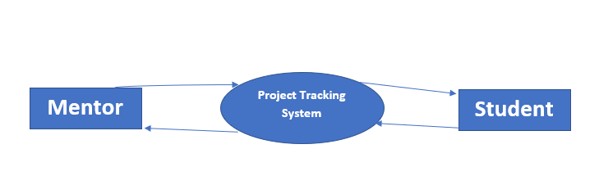

Level 0

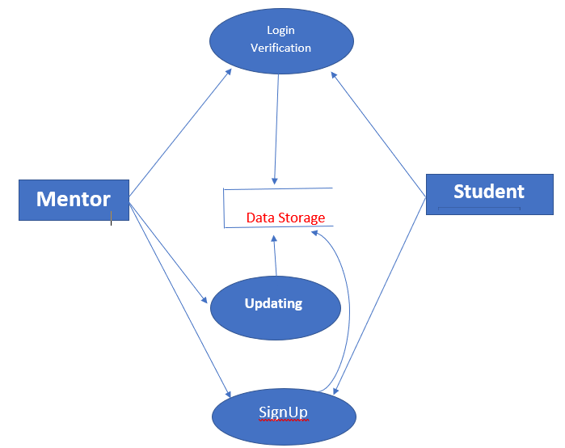

Level 1

**Use Case Diagram:**

**Student**

**Mentor**

**Choose Mentor**

**Update Project Details**

**Feedback**

**SignUp**

**Logout**

**Login**

**Flow Chart**

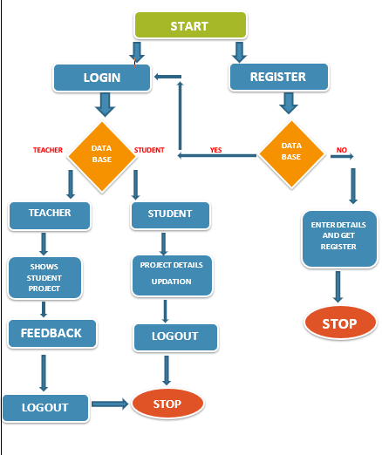

**Scope Of Project**

Project management System is a simple but quite versatile system which consists of the following connected subsystems.

* Android
* Firebase
* User Interface

Receiving data from the user end, both mentor as well as student , it stores that data in the online database - Firebase, through wireless network. And according to the user’s preference, the changes in the details of the project can be made and feedback can be given by the mentor as well.

**Reference**

* <https://doc.qt.io/qt-5/android.html>
* <https://developer.android.com/studio/intro/?gclid=Cj0KCQiAtvPjBRDPARIsAJfZz0o0Ci08uGavXtrNiq7cV7dOJDT8fcbMnPmUJY_4eMyF3xqX7ngnzS8aAhMEEALw_wcB>
* <https://www.youtube.com/watch?v=EkjaiDsiM-Q&list=PLS1QulWo1RIZiBcTr5urECberTITj7gjA>
* <https://felgo.com/doc/>